

**MOD002602 Computing Research Methodologies**

**Element 010: 3000 WORD REPORT (2019 TRI2 F01CAM)**

**Project Title:** UNCONGESTED OUTLET DETECTION METHOD BASED ON ACCESS POINT MAPPING

**Student ID:** 1824482

**Submission Date:** 11/05/2020

**Word Count: 2782 (excluding References)**

**Table of Contents**

**Abstract** 3

**1.** **Introduction** 4

**2.** **Problem Background** 4

**3.** **Research Aim** 5

**4.** **Research Objectives** 5

**5.** **Scope** 5

**6.** **Literature Review** 6

**7.** **Research Methodology** 7

**7.1** **Research Framework** 9

**7.2** **Gantt Chart** 10

**7.3** **Data Collection Strategy** 11

**8.** **Results and Discussion** 11

**9.** **Conclusion** 12

**10.** **References** 13

# 

# **Abstract**

With the advancement of technology and easy at-home availability of services to the customers, people have now become habituated to instant results. People spend a large amount of time in purchasing goods and services which can be reduced by visiting less congested outlets. This would automatically imply shorter queues and easier navigation in the outlets along with lesser demand experienced by the network. The crowd in different outlets of the same brand is never equally distributed and varies with time. There are a number of Wi-Fi routers inside and around every outlet. If their networks are not secured properly, they can be used for access point mapping. In this paper, we propose a novel approach that helps the user to select an uncrowded outlet that is close to them and has the least traffic. Building on existing papers that show how to calculate crowd density through Bluetooth, RF frequencies, and image processing of CCTV footage, this research aims to calculate the crowd density of any locality with the help of access point mapping or war driving. This strategy can be further expanded to search for a particular product at the best price through several outlets. Besides ensuring less congested outlets, it can also help to reduce road traffic, as well as encourage equality of income for the outlets. In a pandemic like Covid-19 this strategy can also be effective by helping people stay away from overcrowded areas.

1. **Introduction**

Time, is the most valuable thing that a man can spend. Individuals should utilize their time appropriately. Even if the future is unseen, buckling down today increase the likelihood of a better future. Figuring the crowd density is critical both from a socio-political and a safety point of view. Crowd distribution is a challenging issue in the management and design levels.

Herd mentality, portrays how individuals can be affected by their peers to adopt certain practices on an emotional, less rational basis. We like to follow a certain routine, visit outlets that we have prior experience with or that our suggested by our peers. Every person spends a substantial amount of time in purchasing goods and services. This time can be reduced by visiting less congested outlets, making shopping more efficient.

In computer vision region, crowd density estimation is an imperative subject. Its undertaking is to evaluate the quantity of individuals around/inside a spot. A Wireless Access Point (WAP) is a local area network (LAN) hardware system or configured node that allows wireless devices and wired networks to communicate via a wireless standard, like Wi-Fi or Bluetooth. WAPs feature radio and antennae transmitters that enable communication between devices and the Internet or a network.

The practice of going around a geographical region and measuring the population of wireless access points for any purposes is called war driving or access point mapping. This paper provides a method to derive the crowd density distribution using war driving along a route.

Wireless data collection advancements, however, can catch crowd elements by scanning mobile phones. Data collection that exploits smartphones has good use and is useful because of its low cost. We’ll use a program called StumbVerter and Microsoft map point to plot the crowd density map. The rest of the research is organized as follows. In section 2, we define the problems faced by a lot of people, which led to the development of this approach. Sections 3, 4 and 5 list the ultimate objectives of this research. Existing literature relative to our study is listed in section 6. Section 7 shows how the research will be carried out, including all the steps. Section 8 and 9 list the results obtained and conclusions formed.

1. **Problem Background**

As instant purchases and results are now available at one’s finger tips, getting things done as soon as possible has become the new norm.

There are many factors that affect the crowd density distribution .There is an unequal crowd distribution in outlets selling the same items or providing the same services.

Outlets that get less crowd make less profit even after investing the same in resources. The crowd in different outlets of the same brand is never equally distributed and varies on different days.

Even on a given day, the crowd density varies according to the time. People visit crowded stores, wait for their turns and spend time in this process which could be utilized elsewhere. If we can provide users with a crowd density distribution map of their localities, they can navigate easily and save the time spent on waiting in queues and at traffic signals.

The current development relates by and large to deciding crowd congestion, and especially, to deciding crowding in a location dependent on the user's movement.

Usually, crowd density might be estimated by ascertaining the thickness of accelerometer gadgets (i.e., passerby gadgets, for example, mobile gadgets, fit for gathering accelerometer information).

This invention relates to accessing wireless services by war driving to locate & map wireless access points that provide access to the details about the router.

1. **Research Aim**

In this paper, we propose a novel approach to detect less crowded outlets, and display their distance and population density on a map. We’ll use access point mapping/war-driving techniques to calculate the crowd density at any selected time. The findings of our study would then be considered along with the data from GPS services to develop an effective map of stores/outlets in a locality.

1. **Research Objectives**

There is a need to provide users with data about the conditions of outlets which are accessible to them and not crowded. This research is expected to address the following objectives:

It will show the population density at a given store/outlet, its distance from the user and the traffic conditions along this route.

It will also show the shortest route and the approximate time required to reach an outlet based on user’s mode of transport, with the help of Google maps.

It will help in maintaining an equal distribution of customers across different outlets. Hence, more profit and less crowd.

It will reduce the city’s traffic and make shopping a fun and less time consuming activity.

1. **Scope**

* This research can help people discover less crowded outlets and hence, save their precious time.
* This research can be developed further to display ‘dangerous spots’ (crowded places with many reported cases of the infection) during a pandemic.
* It could also be developed further to search for a specific product at the best price across several outlets and show product reviews based on the user’s rating. Once established, this application will reduce city traffic by suggesting better routes.
* It would make shopping a less time consuming activity.
* Another benefit of this technique is risk mitigation during mass gatherings where people’s movement needs to be monitored to ensure the safety of the people.

1. **Literature Review**

General overview of this research was presented in the previous section. This section reviews the literature and techniques associated with access point mapping/war driving. It brings up the holes in the current literature and discusses its major advantages and disadvantages.

Wireless access points (WAPs) are networking devices that allow Wi-Fi devices to connect to a wired network. They form wireless local-area networks (WLANs). This section begins with a discussion on access point mapping, and its scope & applications.

Different broadband wireless administrations are ordinarily utilized by users of computers, PDA's, phones, and so on. Broadband wireless administrations are ordinary in homes, workplaces, and other open foundations, for example, cafés, air terminals, and so on. If these network are not secured properly, they can be used for access point mapping.

Byers, Simon & Kormann, David. (2003) define access point mapping as a technique that exploits wireless networks by unauthorized usage of poorly secured wireless local area networks. Access point mapping (also called war driving) involves driving around a locality or city to search for open wireless local area networks.

Because of the expansion of wireless cards and mobile computing gadgets, AP mapping is both simple to do and effective once it is performed. The full scope of casual network finding from a scan from one building to point by point mapping of a city, should be possible with relatively less assets. It yields substantial short & long term advantages to the individuals who can utilize the information produced by war driving. At the point when wireless coverage data is gathered with a level of thoroughness, adequate quality and scale can be accomplished to allow use in front line data mining exercises that yield significant financial, social, and technological outcomes.

According to the research [2], “*the rapid deployment of smartphones as all-purpose mobile computing systems has led to a wide adoption of wireless communication systems such as Wi-Fi and Bluetooth in mobile scenarios.”* Both communication systems leak information to the surroundings during operation. This information has been used for tracking and crowd density estimations in literature. It presents and evaluates three approaches in order to improve the accuracy in comparison to a naive count of captured MAC addresses.

F. Tofigh, G. Mao, J. Lipman and M. Abolhasan (2018) discuss in their paper "Crowd Density Mapping Based on Wi-Fi Measurements on Train Platforms”, the detailed steps required to generate final heat density maps that are in good agreement with the CCTV footage.

Much work on crowd density measurement applies to the processing of video records from security cameras [4, 5]. Be that as it may, this methodology is not doing the job of identifying basically elevated crowd density. Initially, as previously said, it's tough to get a glimpse of the audience actually noticeable. In fact, the lighting conditions at a display would possibly not be sufficient for video-based crowd density monitoring.

According to [6], “*Most of the traditional pedestrian monitoring technologies focus on counting pedestrians passing through a fixed location in the network.”* Thus the movement of individuals or groups cannot be tracked anonymously as they move outside the range of each particular sensor. Moreover, most agencies do not have continuous counts of pedestrians, due mainly to technological limitations.

StumbVerter is a freeware program written by Michael Puchol that takes input data from NetStumbler and plots the access point on Microsoft Mappoints maps.

The paper builds on previous work directed to use war driving scans to analyze crowd distributions.

In the present paper, we’ll use war driving to generate an estimation of the crowd density. The new approach that we take in this research is the collective use of GPS services as well as the data obtained by war driving to obtain the shortest and least congested route to any outlet.

1. **Research Methodology**

As it has been discussed in the previous sections, the major problem that is addressed by this research is the implementation of war driving to calculate the population density around an outlet. When more than one access points are recognized in a similar location as an unmapped access point (having an obscure location), the location of the unmapped access point can be resolved as a function of a weighted average of the known locations of the different access points and signal strength of the signal obtained from access point.

Typical War Driving setup

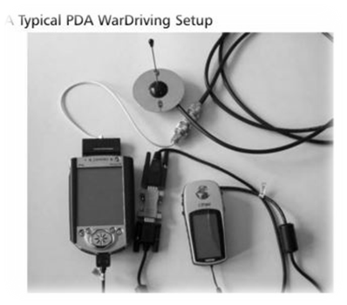

* Typically one of the following methods for determining the positioning of a mobile phone is used:
* Receiver of the Global Positioning System (GPS) in the cell phone
* Reference triangulation.
* Timing of signal checks.
* An analysis of the signal force.
* Nearby gadget information (containing GPS or multiple components).

Each of these methods has points of interest and weaknesses. Appropriately, there is a requirement for a remote cell phone framework and strategy that is arranged to accomplish better goals of location precision. This can be implemented using war driving.

When we go for a War drive, we gain information about the Wireless Access Points along our route. We can map this data to determine:

* Monitoring the increase/decrease of wireless network in some areas.
* The change in number of wireless users
* SSID, MAC Address of various routers

We will use this data to obtain an approximate crowd density near various routers along our route with the use of a freeware program StumbVerter. We will use Microsoft’s Mappoint to map the access points in a locality and compare it with the GPS based Google map of the same area to formulate the results and conclusions.

**Example**: **War driven data on Netstumbler**:

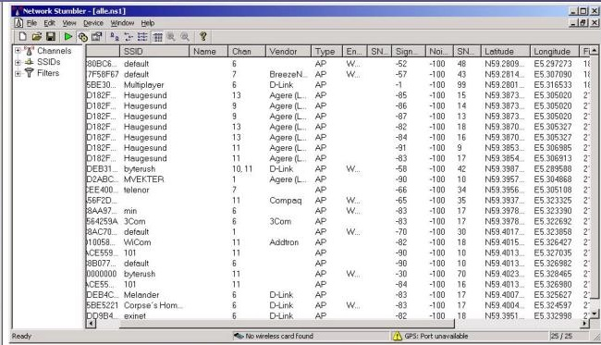

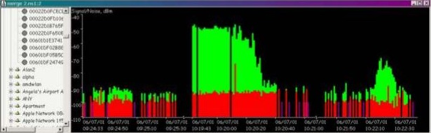

**Screenshot of NetStumbler, by Marius Milner, from http://home.pacbell.net/mariusm/**

This paper builds on previous work directed to use war driving scans to analyse crowd density and extends it with more advanced features. This research consists of a number of steps, which are explained in the next section.

**Expected map** **by:** Michael Puchol (Sonar Security), from http://www.sonar-security.com

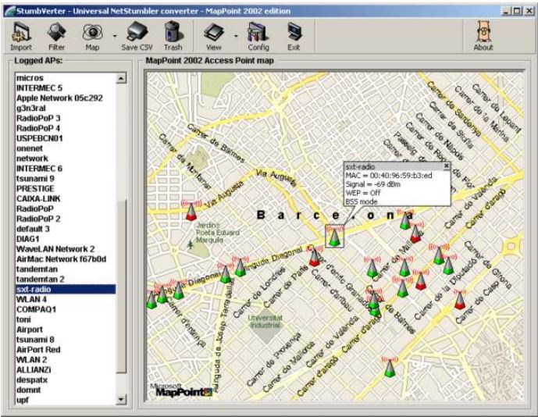

## **Research Framework**

This section gives a brief description of the research framework, which is listed in the following block diagram. The main steps involved in this research are:

1. Asking the name/type of the outlets the user wants to visit
2. Use GPS on Google maps to get the distance of these outlets from the user along with the traffic condition on this route.
3. Use of war driving on the Wi-Fi routers near these outlets.
4. Use of the war driven data to create a map that shows the population density around various stores.
5. Using the data obtained in steps 2 and 4 to create a map which displays the population density, distance & traffic conditions along the route.
6. Start navigation after the user selects his preference of outlet.

Block Diagram on the next page:

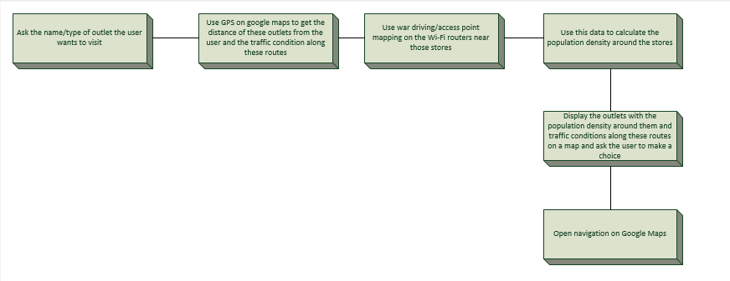

## **Gantt chart**

The schedule of this research project is illustrated in the following Gantt chart:

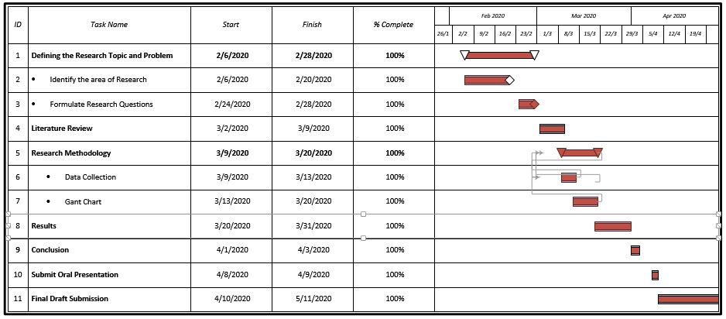

## **7.3 Data Collection Strategy**

This research uses both primary and secondary datasets.

Dataset A: Primary data is the data collected for the first time in a research. Dataset A was prepared as a part of this research. It comprises of the war driven data collected by us and the mapping of crowd density along the war driving route.

Dataset B: Secondary data is the data which has already being collected by someone. Dataset B is the data available on Google maps for any given outlet. This includes the distance, directions & traffic conditions for the route. This data varies with time and mode of transport, hence, we can export the dataset B through Google maps.

Dataset C: Dataset C is the final dataset generated by our study. It shall contain the location, crowd density, traffic conditions, opening time etc.

Data Analysis Strategy: We’ll analyse the collected data with the help of Google Maps and Microsoft Map point.

1. **Results and Discussion**

In the previous section, the overview of the research methodology and its elements was presented. This section focussed on the findings of our research along with an unbiased discussion on them.

Expected outcomes:

* This research resulted in the formation of an approach that can calculate the approximate crowd around different outlets and hence, helped the user to visit an uncrowded outlet in proximity.
* It helped in maintaining an equal distribution of customers across different outlets. Hence, it made shopping a less time consuming activity.
* The accuracy of this research would have increased if we had increased the number of users as the war driven dataset would be large and precise.
* This research ensured that all stores/outlets made similar profit on the same investment, thus promoting income equality.

Ultimately, our research decreased the traffic congestion by a good amount. This resulted in people being more effective. By reducing traffic, it made shopping less tedious and eco-friendly.

1. **Conclusion**

* This research resulted in an approach that could detect uncongested shopping outlets. It could be developed further to search for a specific product that the user needs. Once the user selects the product, he can view its price across various outlets and the crowd density across these outlets. We can ask for the user’s review on the product they purchased and these reviews can further help potential customers.
* Large events on a regional scale draw hundreds of thousands of footmen. These pedestrians need to be actively tracked to identify hazardous crowd conditions at an early stage and to reduce the possibility of developing into dangerous accidents. Another benefit of this technique is risk mitigation during mass gatherings where people’s movement needs to be monitored to ensure the safety of the people. Apart from these, this approach can also prove to be helpful during the times of a pandemic such as Covid-19 by helping people decide how safe the outlets in their localities are by providing the correct figures to them.
* Once established, this application will reduce city traffic by suggesting better routes. Reduced traffic implies less fuel consumption, therefore our research is eco-friendly and sustainable.

1. **References**
2. Blight, D., 2020. US20020184418A1 - Location Mapping And Determining Using Wireless Devices - Google Patents. [online] Patents.google.com. Available at: <https://patents.google.com/patent/US20020184418A1/en> [Accessed 21 April 2020].
3. Byers, Simon & Kormann, David. (2003). 802.11B access point mapping. Commun. ACM. 46. 41-46. 10.1145/769800.769824
4. F. Tofigh, G. Mao, J. Lipman and M. Abolhasan, "Crowd Density Mapping Based on Wi-Fi Measurements on Train Platforms," 2018 12th International Conference on Signal Processing and Communication Systems (ICSPCS), Cairns, Australia, 2018, pp. 1-7.
5. Hurley, C., 2004. Wardriving: Drive, Detect, Defend: A Guide To Wireless Security. 1st ed. Washington: Syngress Publishing,.
6. J. Weppner and P. Lukowicz, "Bluetooth based collaborative crowd density estimation with mobile phones," 2013 IEEE International Conference on Pervasive Computing and Communications (PerCom), San Diego, CA, 2013, pp. 193-200.
7. K. Ping, P. Bo, Z. Wenying and L. Shuai, "Research on central issues of crowd density estimation," 2013 10th International Computer Conference on Wavelet Active Media Technology and Information Processing (ICCWAMTIP), Chengdu, 2013, pp. 143-145.
8. Krausz B, Bauckhage C. Loveparade 2010: automatic video analysis of a crowd disaster. Comput Vision Image Understand. 2012, pp. 307–19.
9. Li T, Chang H, Wang M, Ni B, Hong R, Yan S. Crowded scene analysis: a survey. IEEE Trans Circ Syst Video Technol. 2015, pp. 367–86.
10. Nicopolitdis. and Nicopolitidis, P., 2003. Wireless Networks. Singapore: John Wiley and Sons, pp. 147-59
11. Pahlavan, K. and Krishnamurthy, P., 2013. *Principles Of Wireless Access And Localization*. Chichester, West Sussex, U.K.: John Wiley & Sons Inc., pp. 77-132.
12. Sciencing. 2020. How To Estimate Crowd Density. [online] Available at: <https://sciencing.com/estimate-crowd-density-7824574.html> [Accessed 17 April 2020].
13. Weaver, R., Weaver, D. and Farwood, D., n.d. *Guide To Network Defense And Countermeasures*.

**Mark scheme for Element 010: 3000 WORD REPORT (2019 TRI2 F01CAM)**

**MOD002602 Computing Research Methodologies**

**Project Title : ----------------------------------------------------------**

**Student ID : ----------------------------------------------------------**

|  |  |  |  |  |  |  |  |  |
| --- | --- | --- | --- | --- | --- | --- | --- | --- |
|  |  | **Content (40 %)** | | | **Structure (40 %)** | | | **Total** |
| # | **Section** | **Not Yet**  **1/6** | **Good**  **1/3** | **Excellent**  **1/2** | **Not Yet**  **1/6** | **Good**  **1/3** | **Excellent**  **1/2** |  |
| **1** | **Project Title** |  |  |  |  |  |  | **Out of 5** |
| **2** | **Abstract** |  |  |  |  |  |  | **Out of 5** |
| **3** | **Introduction** |  |  |  |  |  |  | **Out of 5** |
| **4** | **Problem Background** |  |  |  |  |  |  | **Out of 10** |
| **5** | **Research Aim and Objectives** |  |  |  |  |  |  | **Out of 5** |
| **6** | **Scope** |  |  |  |  |  |  | **Out of 5** |
| **7** | **Literature Review** |  |  |  |  |  |  | **Out of 10** |
| **8** | **Research methodology** |  |  |  |  |  |  | **Out of 10** |
| **9** | **Expected Outcomes** |  |  |  |  |  |  | **Out of 10** |
| **10** | **Conclusion** |  |  |  |  |  |  | **Out of 5** |
| **11** | **References** |  |  |  |  |  |  | **Out of 10** |
| **SUBTOTAL** | | | | | | | | **Out of 80** |